Purpose : This Doc describes the Use Case Diagram of the ADMIN module and brief description of functionalities of the admin.

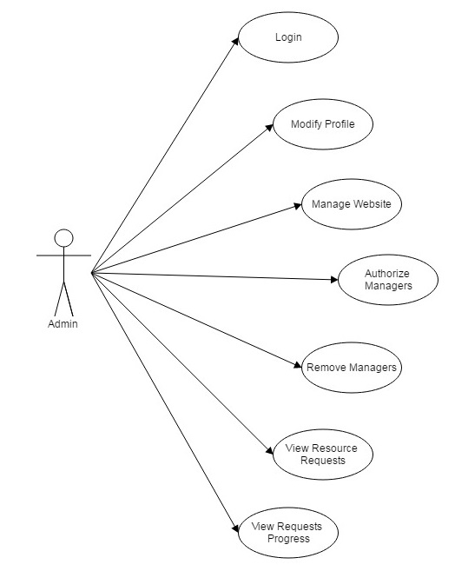

2. ADMIN --

    - Login :
Module to login for Admin.

    - Modify Profile :
Admin should be able to modify its own profile such as change of contact number, change of profile picture, etc.

    - Manage Website :
Admin should have all the access of the website so that admin can do all the necessary changes required to maintain the website.

    - Authorize Managers :
Admin should have to verify the managers to ensure that the profile made by the employee is correct and after approval of the admin, managers can have the access to the features provided to them in the website.

    - Remove Managers :
Admin can remove the managers in case if manager leaves the organization or the designation of the manager is changed.

    - View Resource Requestst :
Admin can view the list of resources asked by the employees along with the name of the employees who have requested that resource and the approval status of the request given by managers.

    - View Requests Progress :
Admin can also view the current status of the approved requests to ensure the delivery of the resource.

